Architectural Design Campus Placement Prediction

Revision Number: 1.8

K.Jayanthi

# Document Version Control

|  |  |  |  |
| --- | --- | --- | --- |
| **Date Issued** | **Version** | **Description** | **Author** |
| **20th sept 2022** | 1.1 | First Draft | K.Jayanthi |
| **22th sept 2022** | 1.2 | Added Workflow chart | K.Jayanthi |
| **22th sept 2022** | 1.3 | Added Exception Scenarios Overall,  Constraints | K.Jayanthi |
| **25th sept 2022** | 1.5 | Added user I/O flowchart | K.Jayanthi |
| **30th sept 2022** | 1.7 | Added dataset overview and updated user I/O flowchart. | K.Jayanthi |
| **02nd oct 2022** | 1.8 | Restructure and reformat LLD | K.Jayanthi |

**Contents**

Document Version Control 2

1. Introduction 4
   1. Why this Low-Level Design Document? 4
   2. Scope 5
   3. Constraints 5
   4. Risks 5
   5. Out of Scope 5
2. Technical specifications 6
   1. Dataset 6
      1. Campus placement prediction dataset overview 6

File descriptions 6

Data fields 7

* + 1. Input schema 7
  1. Predicting the results 8
  2. Logging 8

1. Technology stack 9
2. Proposed Solution 9
3. Model training/validation workflow 10
4. User I/O workflow 11
5. Exceptional scenarios 11
6. Test cases 11

**Abstract**

Placement of students is one of the most important objective of an educational institution. Reputation and yearly admissions of an institution invariably depend on the placements it provides it students with. Institutions make great efforts to achieve placements for their students’ .This will always be helpful to the institution. The objective is to predict the students getting placed for the current year by analyzing the data collected from previous year’s students. This model is proposed with an algorithm to predict the same. The data has been collected by the institution for which prediction is going to be done and by applying suitable data pre-processing techniques. This model is prepared by using Support Vector Machine [SVM] algorithm. This algorithm independently predict the results and we then compare the efficiency of the algorithm, which is based on the dataset. This model will helps the placement cell to focus on the potential students and help them to improve their technical and social skills.

# Introduction

## Why this Low-Level Design Document?

The purpose of this document is to present a detailed description of the Campus Placement Prediction System. It will explain the purpose and features of the system, the interfaces of the system, what the system will do, the constraints under which it must operate and how the system will react to external stimuli. This document is intended for both the stakeholders and the developers of the system and will be proposed to the higher management for its approval.

The main objective of the project is to predict whether a student is placed or not based on the given dataset.

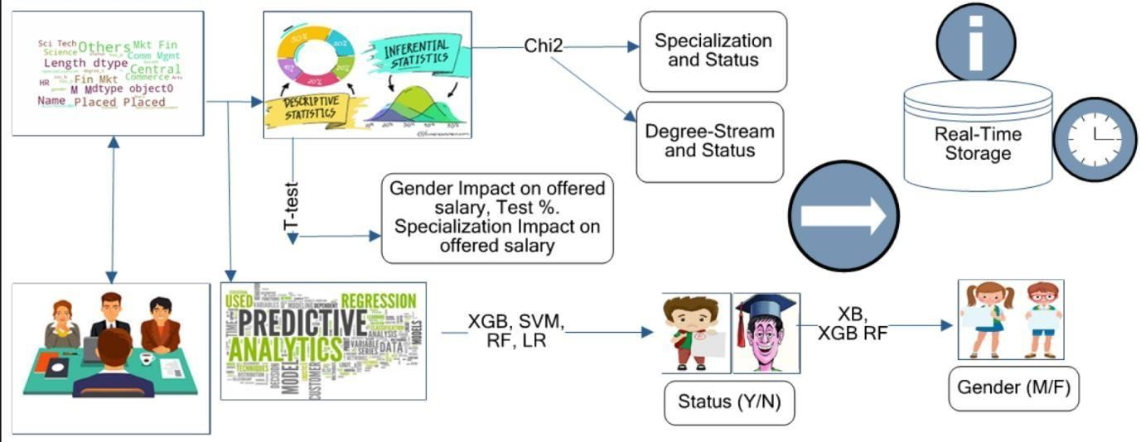

* 1. **Scope**

We have designed a models for checking prediction of student getting placed or not in a campus drive this model will help both student and institutions for preparing well in advance for campus recruitment. The main objective of this model is to know the capability of the student and where he stands by predicting the probability of getting placed. This also help the students and institutions to improve performance of the potential students. This model will consider the academic history of the student such as percentage as well as their domains and specializations which are tested by companies. We used SVM algorithm on the student’s data gathered from the institution of previous year. This model take scores of student in secondary education along with academic CGPA of both UG and PG.in the technical education till date and also some parameters which adds weightage to kick start the career.

**Constraints**

We will only be selecting a few of the educational parameters.

**Risks**

Document specific risks that have been identified or that should be considered.

* 1. **Out of Scope**

Delineate specific activities, capabilities, and items that are out of scope for the project.

# Technical specifications

## Dataset

|  |  |  |
| --- | --- | --- |
| **Parameters** | **Finalized** | **Source** |
| * gender - sex of the student * secondary education percentage-marks obtained in secondary education * higher secondary percentage-marks obtained in higher secondary education * degree percentage- marks obtained in degree * Under- graduation(Degree- type)-Field of degree education * Work-experience * Employability-test- package * specialisation-field of study | yes | https:/[/www.kaggle.com/c/ml-with-python-](http://www.kaggle.com/c/ml-with-python-) course-project/data |

* + 1. **Campus placement prediction dataset overview**

File descriptions

* + - * train.csv - the training set
      * test.csv - the test set
      * SampleSubmission.csv - a sample submission file in the correct format.

Data fields

* + - * gender - sex of the student
      * secondary education percentage-marks obtained in secondary education
      * higher secondary percentage-marks obtained in higher secondary education
      * degree percentage-marks obtained in degree
      * Under-graduation(Degree-type)-Field of degree education
      * Work-experience
      * Employability-test-package
      * specialisation-field of study

There are a total of 250 students in the training set.

* + - * + Student information table with various parameters

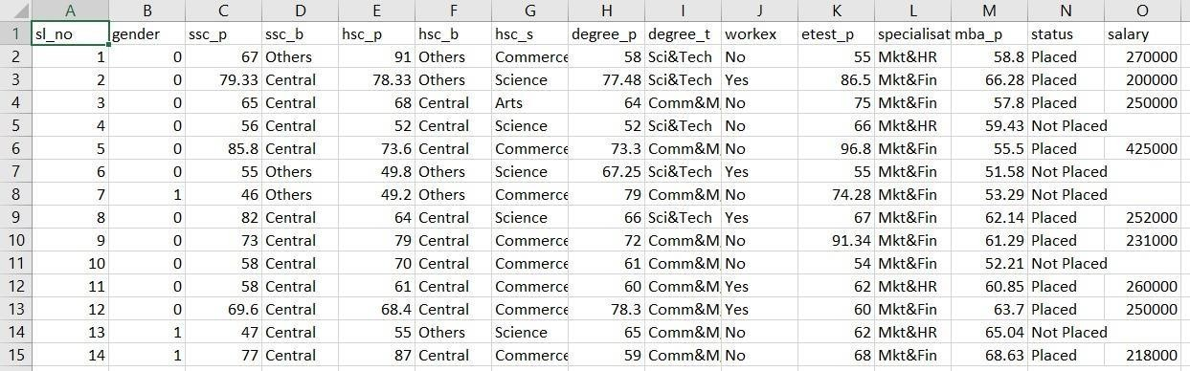

* + 1. **Input schema**

|  |  |  |  |
| --- | --- | --- | --- |
| **Feature name** | **Datatype** | **Size** | **Null/Required** |
| Gender | char | 10 | Required |
| Secondary education percentage[10th %] | float | 5 | Required |

|  |  |  |  |
| --- | --- | --- | --- |
| Higher Secondary education percentage[12th %] | float | 5 | Required |
| Specialisation in higher secondary education | String | 20 | Required |
| Degree percentage | float | 5 | Required |
| Under graduation | String | 10 | Required |
| Work Experience | char | 1 | Required |
| Employability test percentage | float | 5 | Required |
| Specialisation | String | 10 | Required |
| MBA percentage | float | 5 | Required |

* 1. **Predicting the results**
* The system displays the choices to various fields as mentioned.
* The User chooses the target by clicking one of the available options.
* The system presents the set of inputs required from the user.
* The user gives required information.
* The system should be able to predict whether the student gets placed or not based on the user information.
  1. **Logging**
* We should be able to log every activity done by the user. The System identifies at what step logging required.
* The System should be able to log each and every system flow.
* Developers can choose logging methods. You can choose database logging/ File logging as well.
* System should not hang even after using so many loggings. Logging just because we can easily debug issues so logging is mandatory to do.
  1. **Deployment**
     1. HEROKU



# Technology stack

|  |  |
| --- | --- |
| **Front End** | HTML/CSS/JS |
| **Backend** | Python Flask |
| **Deployment** | HEROKU |

# Proposed Solution

The placement prediction model considers only academic performances of the students so that the prediction of the student getting placed or not can be done. We cannot consider the placement of students just by their academic performances because some students may be good at aptitude, technical and communication skills due to their low score in their academic that may tend to be their drawback. For predicting the placement of a Student needs parameters like cgpa, logical and technical skills Academic performances may be important but the model is design to predict the placements based on the parameters of the student.

# Model training/validation workflow

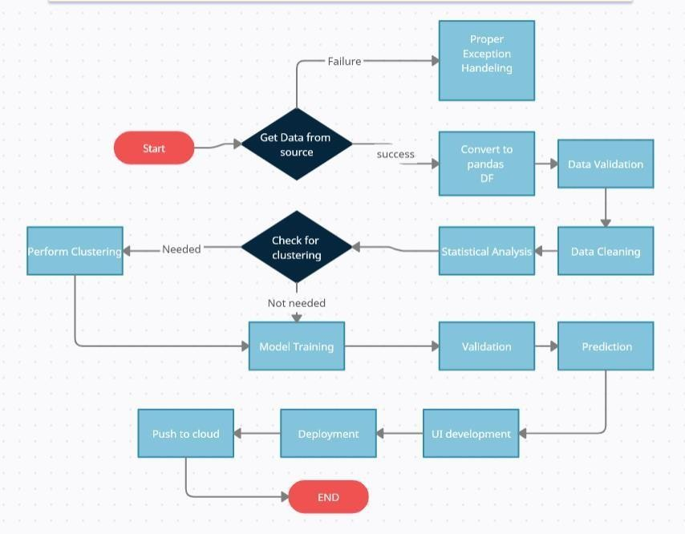

# User I/O workflow

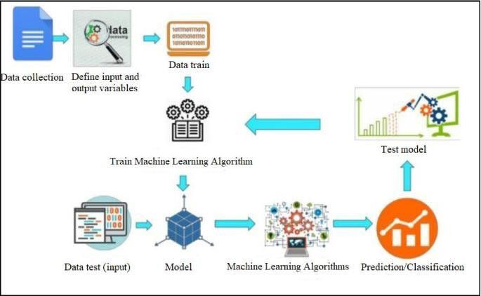

# Exceptional scenarios

|  |  |  |  |
| --- | --- | --- | --- |
| **Step** | **Exception** | **Mitigation** | **Module** |
| **24th April 2022** | 1.1 | First Draft | Yashika A Pawar |
| **1st May 2022** | 1.2 | Added Workflow chart | Yeshaswini C |

# Test cases

|  |  |  |  |
| --- | --- | --- | --- |
| **Test case** | **Steps to perform test case** | **Module** | **Pass/Fail** |
|  |  |  |  |